ASMi BUSINESS SCHOOL
SPEAKER DIRECTORY
April - September 2026

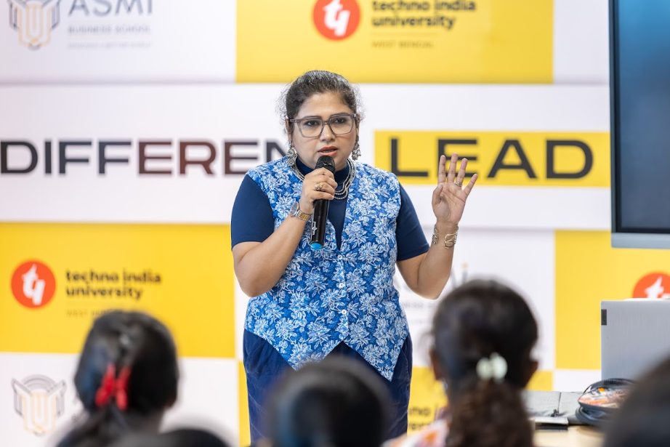 | 6 October 2026  Samhita Dutta  Head HR & Global operation A4 technologies Solution inc. USA  Event: Corporate Connect Session

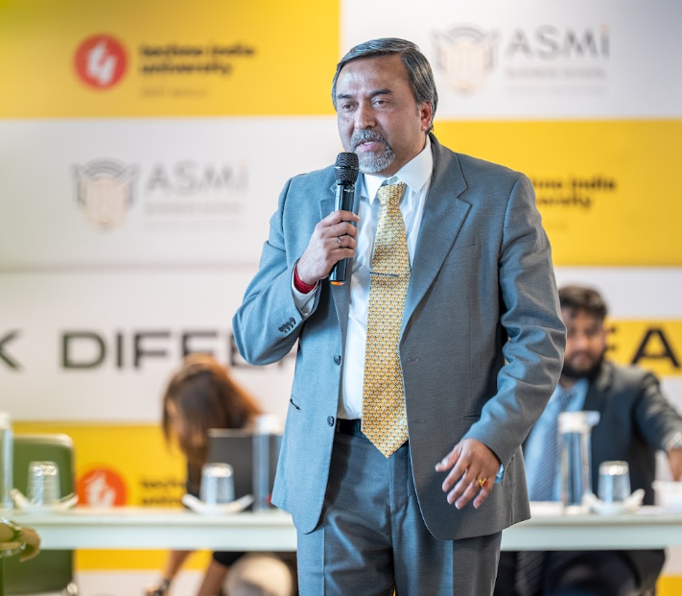 | 19 AUGUST 2026  Mainak Roy  Financial Controller, London Borough of Brent, London  Event: The ASMi Finance Marathon 2026  Report source: 19.8.26 FINANCE MARATHON REPORT_ASMI_2026-2027 (1).pdf

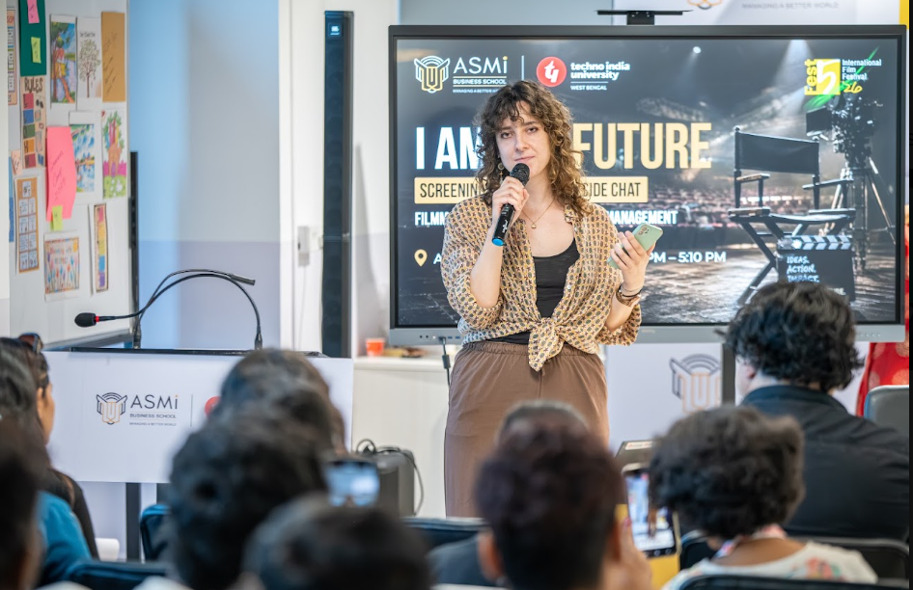 | 26 AUGUST 2026  Pilar Parodi Felix  Director, Deauville Green Awards  Event: I Am The Future - Movie Screening & Creator Fireside Chat  Report source: 26.8.26 FILM SCREENING REPORT (1).pdf

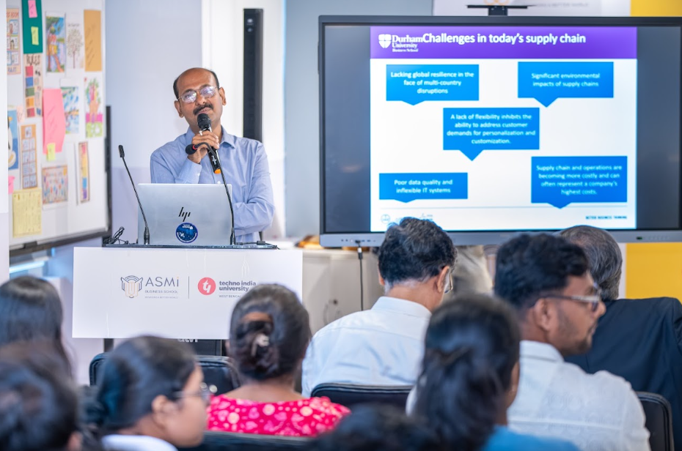 | 1 SEPTEMBER 2026  Prof. Atanu Chaudhuri  Professor of Technology and Operations Management, Durham University Business School, UK  Event: Session on Supply Chain Management  Report source: 1.9.26 ASMI_Supply_Chain_Management_Session_Report_2026-1.docx

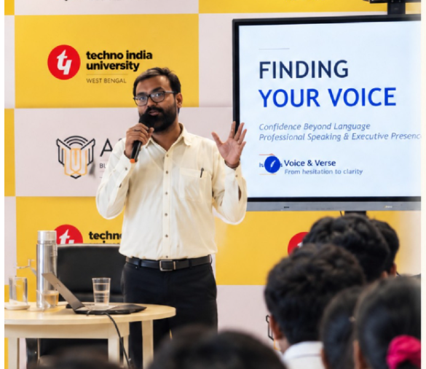 | 8 SEPTEMBER 2026  Mr. Reeju Pathak  PGT Teacher, Eklavya Model School, Bankura; Founder, Voice & Verse  Event: Finding Your Voice: Confidence Beyond Language  Report source: 8.9.26 Session Sharing-Finding Your Voice.pdf

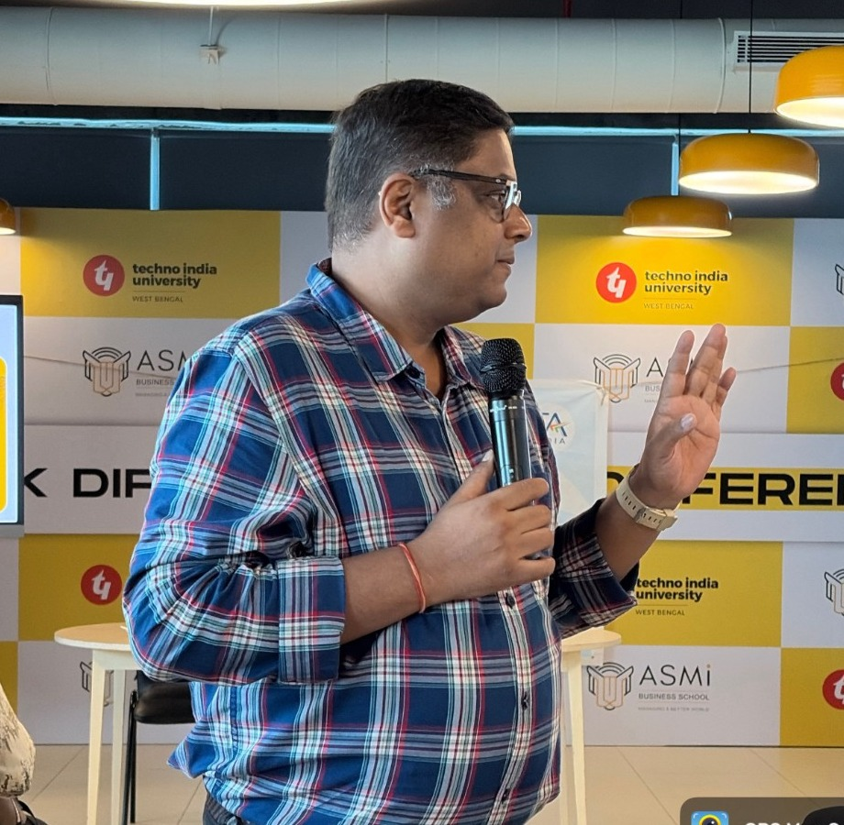 | 16 SEPTEMBER 2026  CA Rahul Rungta  Chartered Accountant (CA) & CFA  Event: ICAI Career Counselling & Awareness Session  Report source: 16.09.26 BBA (2026-30) ICAI Career Counselling Awareness.pdf

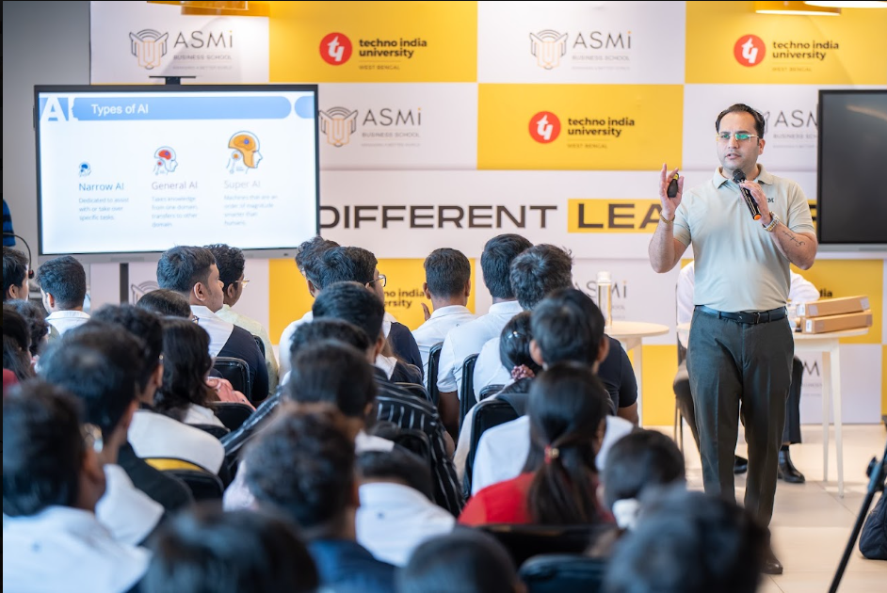 | 22 SEPTEMBER 2026  Mr. Aman Bakshi  Manager, Industrial Engagements & Senior AI & Data Scientist, IBM  Event: IBM Day: TechnoVate 2026  Report source: 22.9.26 IBM Day Technovate 2026 Report.pdf

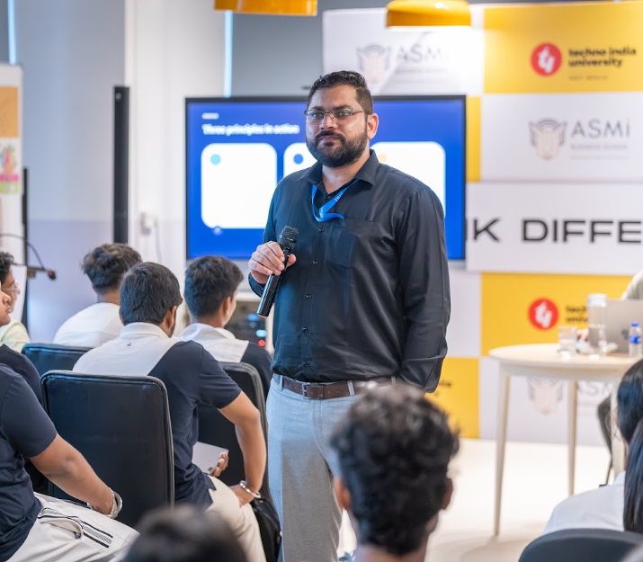 | 22 SEPTEMBER 2026  Mr. Robin Tyagi  Quality Analyst & Cloud Application Developer, IBM  Event: IBM Day: TechnoVate 2026  Report source: 22.9.26 IBM Day Technovate 2026 Report.pdf

Entries without a matching dated report/photo
These speaker entries appear in the Excel schedule, but a corresponding dated report/photo was not found in the provided Drive folder during compilation.
Date | Speaker / Designation | Status
11 August 2026 | Neha Mishra - LinkedIn Brand Strategist; Co-Founder, InstaInker; Founder, Consult Global | 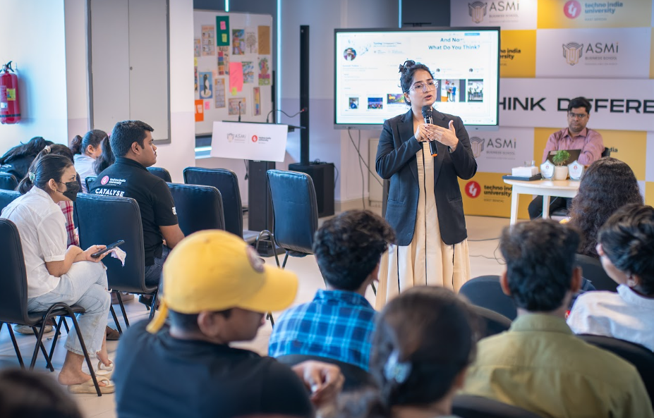.
11 August 2026 | CA Nikhil Bajaj - Founder & Managing Partner, VSNB & Associates; Co-Founder, InstaInker | 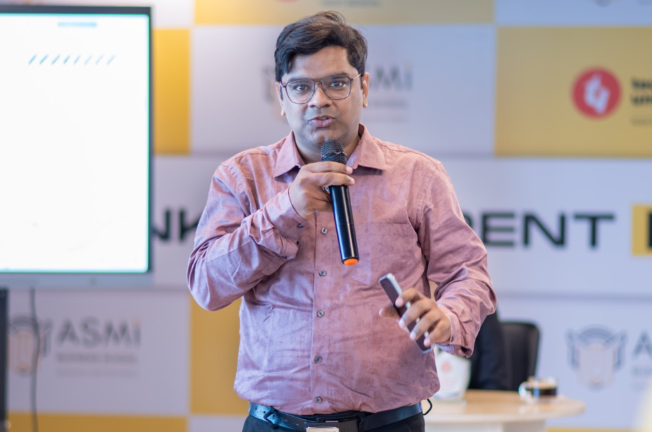
24 September 2026 | Mr. Hritavash Saha - Growth Marketing Lead, APPSeCONNECT | 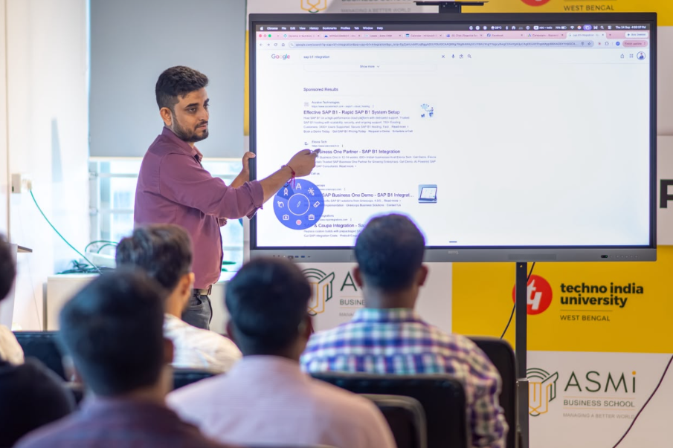
30th Sept 2026 | Kaushik Raha – Principle AI Strategist & GTM Specialist, AWS US | 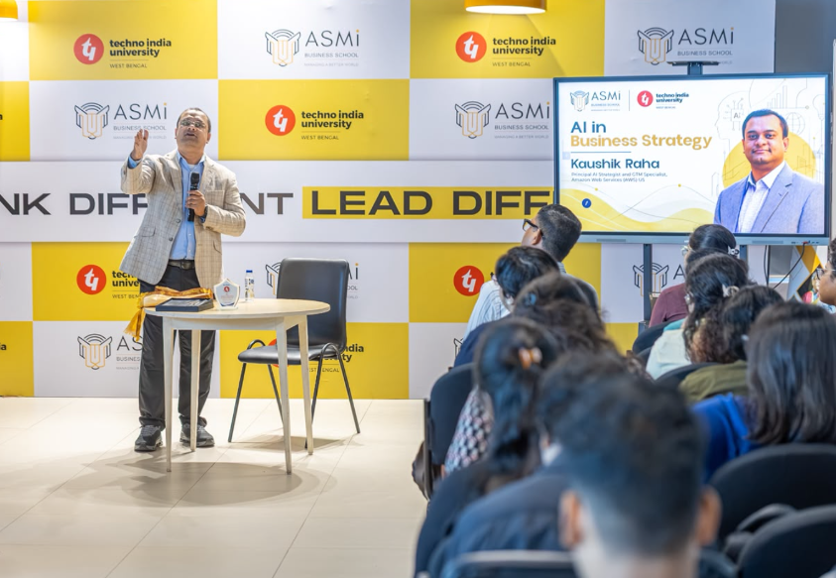
24 September 2026 | Mr. Arindam Tagore - Senior Tax Professional & US Enrolled Agent | 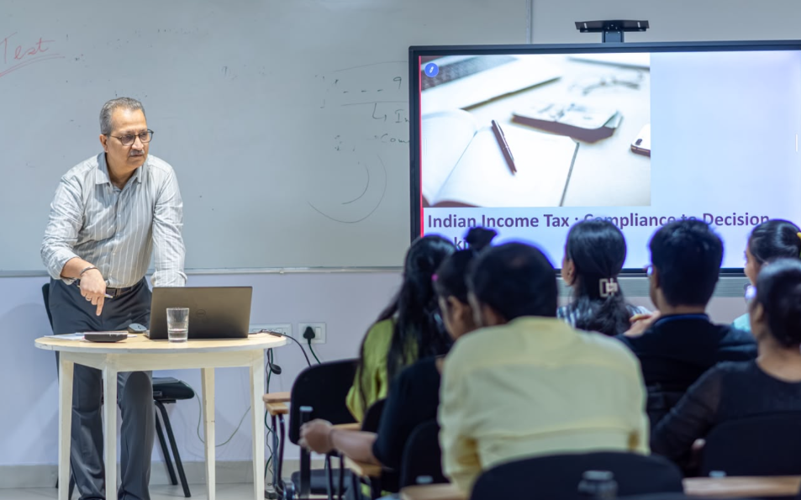
29 September 2026 | Dr. Niloy Biswas - Senior Vice President & Group HR Head, EMC Limited | 